Our World: The Canary Islands

Introduction
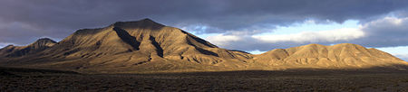
The Canary Islands, also known as the Canaries (Spanish: Canarias), are a Spanish archipelago located just off the northwest coast of mainland Africa, 100 kilometres (62 miles) west of the southern border of Morocco. The Canaries are one of Spain's 17 autonomous communities and are among the outermost region of the European Union proper. The islands include (from largest to smallest): Tenerife, Fuerteventura, Gran Canaria, Lanzarote, La Palma, La Gomera, El Hierro, La Graciosa, Alegranza, Isla de Lobos, Montaña Clara and Roque del Oeste.
The archipelago is a major tourist destination with over 12 million visitors per year, especially Tenerife, Fuerteventura, Gran Canaria and Lanzarote. The islands have a subtropical climate, with long warm summers and moderately warm winters. Due to their location above the temperature inversion layer, the high mountains of these islands are ideal for astronomical observation. For this reason, two professional observatories, Teide Observatory on the island of Tenerife and Roque de los Muchachos Observatory on the island of La Palma, have been built on the islands.
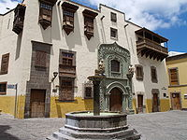
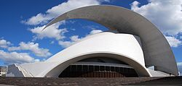
The capital of the Autonomous Community is shared by the cities of Santa Cruz de Tenerife and Las Palmas de Gran Canaria, which in turn are the capitals of the provinces of Santa Cruz de Tenerife and Province of Las Palmas. Las Palmas de Gran Canaria has been the largest city in the Canaries since 1768, except for a brief period in 1910. In 1927 a decree ordered that the capital of the Canary Islands be shared, as it remains at present. The third largest city of the Canary Islands is La Laguna (a World Heritage Site) on Tenerife.

Geography

Tenerife is the most populous island, and also the largest island of the archipelago. Gran Canaria, with 865,070 inhabitants, is both the Canary Islands' second most populous island, and the third most populous one in Spain after Majorca. The island of Fuerteventura is the second largest in the archipelago and located 100 km (62 mi) from the African coast.
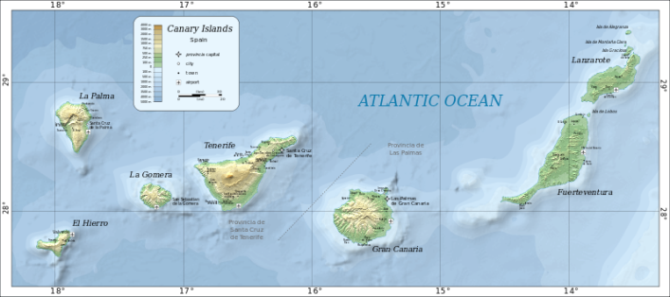

The archipelago consists of seven large and several smaller islands, all of which are volcanic in origin. The islands are considered as a distinct physiographic section of the Atlas Mountains province, which in turn is part of the larger African Alpine System division.

Geology

The originally volcanic islands –seven major islands, one minor island, and several small islets– were formed by the Canary hotspot. The Canary Islands is the only place in Spain where volcanic eruptions have been recorded during the Modern Era, with some volcanoes still active (El Hierro, 2011).
Volcanic islands such as those in the Canary chain often have steep ocean cliffs caused by catastrophic debris avalanches and landslides.
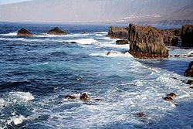

Demographics
The Canary Islands have a population of 2,117,519 inhabitants (2011), making it the eighth most populous of Spain's autonomous communities, with a density of 282.6 inhabitants per km². The total area of the archipelago is 7,493 km2 (2,893 sq mi). Items in red denote ethnicity; items in yellow denote citizenship/naturalization; items in blue denote place of birth.
Nationality | Population | Percent
Canarian | 1,547,611 | 91.5%
Mainland Spanish (Peninsulares) | 178,613 | 8.5%
Total Spanish | 1,802,788 | 85.7%
Foreign nationals | 301,204 | 14.3%
Spanish-born | 1,726,315 | 82.0%
Foreign-born | 377,677 | 18.0%
Total | 2,103,992 | 100%

Islands

El Hierro
El Hierro, the westernmost island, covers 268.71 km2 (103.75 sq mi), making it the smallest of the major islands, and the least populous with 10,753 inhabitants. The whole island was declared Reserve of the Biosphere in 2000. Its capital is Valverde.

Fuerteventura
Fuerteventura, with a surface of 1,660 km2 (640.93 sq mi), is the second-most extensive island of the archipelago. It has a population of 100,929. Its capital is Puerto del Rosario.

Gran Canaria
Gran Canaria has 845,676 inhabitants. The capital, Las Palmas de Gran Canaria (377,203 inhabitants), is the most populous city and shares the status of capital of the Canaries with Santa Cruz de Tenerife.

La Gomera
La Gomera, has an area of 369.76 km2 (142.77 sq mi) and is the second least populous island with 22,622 inhabitants. Geologically it is one of the oldest of the archipelago. The insular capital is San Sebastian de La Gomera. Garajonay's National Park is here.
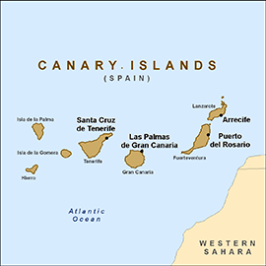

Lanzarote
Lanzarote, is the easternmost island and one of the most ancient of the archipelago, and it has shown evidence of recent volcanic activity. It has a surface of 845.94 km2 (326.62 sq mi), and a population of 139,506. The capital is Arrecife, population 56,834.

Chinijo Archipelago
The Chinijo Archipelago includes the islands La Graciosa, Alegranza, Montaña Clara, Roque del Este and Roque del Oeste. It has a population of 658 inhabitants, all of them on La Graciosa. La Graciosa, is the smallest inhabited island of the Canaries, and the major island of the Chinijo Archipelago.

La Palma
La Palma, with 86,528 inhabitants, covering an area of 708.32 km2 (273.48 sq mi) is in its entirety a biosphere reserve. It is the second-highest island of the Canaries, with the Roque de los Muchachos 2,423 metres (7,949 ft) as highest point. Santa Cruz de La Palma is its capital.

Tenerife
Tenerife is, with its area of 2,034 km2 (785.33 sq mi), the most extensive island of the Canary Islands. In addition, with 906,854 inhabitants it is the most populated island of the archipelago and Spain. The capital, Santa Cruz de Tenerife and San Cristóbal de La Laguna (a World Heritage Site). San Cristóbal de La Laguna, the second city of the island is home to the oldest university in the Canary Islands, the University of La Laguna. The Teide, with its 3,718 metres (12,198 ft) is the highest peak of Spain and also a World Heritage Site.

Wildlife

Terrestrial wildlife
Terrestrial fauna includes geckos (such as the striped Canary Islands Gecko) and wall lizards, and three endemic species of recently rediscovered and critically endangered giant lizard: the El Hierro Giant Lizard (or Roque Chico de Salmor Giant Lizard), La Gomera Giant Lizard, and La Palma Giant Lizard. Mammals include the Canarian Shrew, Canary Big-Eared Bat, the Algerian Hedgehog (which may have been introduced) and the more recently introduced Mouflon. Some endemic mammals, the Lava Mouse, Tenerife Giant Rat and Gran Canaria Giant Rat, are extinct, as are the Canary Islands Quail, Long-legged Bunting, and the Eastern Canary Islands Chiffchaff.
. 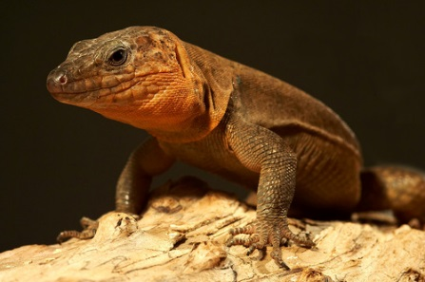

Marine life

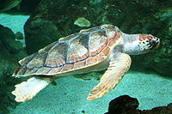
The marine life found in the Canary Islands is also varied, being a combination of North Atlantic, Mediterranean and endemic species. In recent years, the increasing popularity of both scuba diving and underwater photography have provided biologists with much new information on the marine life of the islands.
Fish species found in the islands include many species of shark, ray, moray eel, bream, jack, grunt, scorpionfish, triggerfish, grouper, goby, and blenny. In addition, there are many invertebrate species, including sponge, jellyfish, anemone, crab, mollusc, sea urchin, starfish, sea cucumber and coral.
There are a total of 5 different species of marine turtle that are sighted periodically in the islands, the most common of these being the endangered loggerhead sea turtle. The other four are the green sea turtle, hawksbill sea turtle, leatherback sea turtle and Kemp's ridley sea turtle. Currently, there are no signs that any of these species breed in the islands, and so those seen in the water are usually migrating. However, it is believed that some of these species may have bred in the islands in the past, and there are records of several sightings of leatherback sea turtle on beaches in Fuerteventura, adding credibility to the theory.
Marine mammals include the Short-Finned Pilot Whale, Common and Bottlenose dolphins. Hooded Seals have also been known to be vagrant in the Canary Islands every now and then. The Canary Islands were also formerly home to a population of the rarest Pinniped in the world, the Mediterranean Monk Seal.

List of Useful Spanish Phrases for English Speakers
English | Spanish
Good morning. | Buenos días.
Good afternoon. | Buenos tardes.
Good evening. | Buenos noches.
I want some breakfast. | Yo quiero el desayuno.
Where is the beach? | Donde es la playa?
What is the telephone number? | Cual es el numero de telefono?

